**Out of Class 9-10-21**

Using the same database that was utilized for the 9-3-21 assignment, complete the problems listed below. Here is an ER diagram as well as the tables for the SaleCo Database.

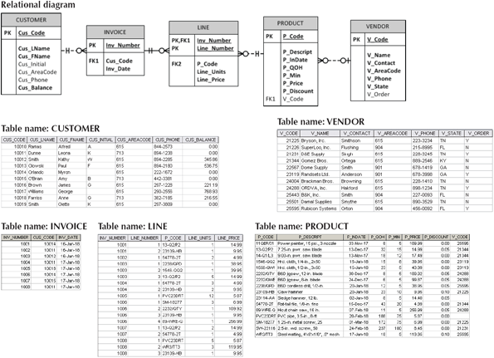

1. Create a query to produce the total purchase per invoice, generating the results shown below, sorted by invoice number. The invoice total is the sum of the product purchases in the LINE that corresponds to the INVOICE.

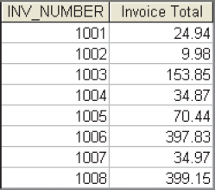

1. Find the total value of the product inventory. The results are shown below.

C:\Users\sawilliams\Pictures\9781337627900_ch07_0239-t2.png

1. Find the total value of the product inventory. The results are shown below.

